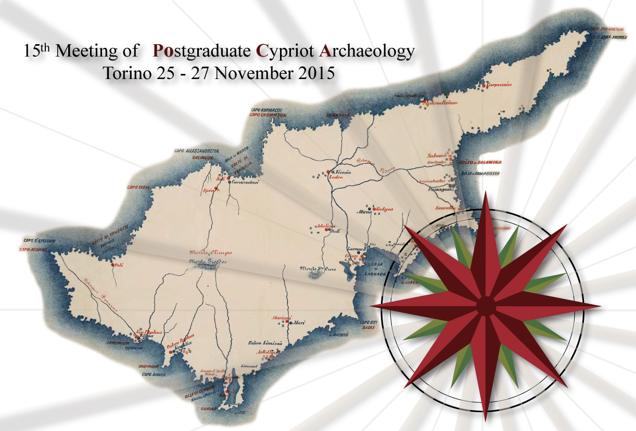

REGISTRATION FORM

First name: ………………………………………Surname:…………………………………………

Institution (if applicable):…………………………………………………………………………….

Address:………………………………………………………………………………………………

..........................................................................................................................................................…

..............................................................................................................................................................

Postcode: ………………………………

Phone: ……………………………………Email: ..........……………………….………….

Please, tick as appropriate: [ ] Presenter [ ] Listener

The conference is Free and participants will need to meet their own subsistence, accommodation and travel costs.

Participation in Conference Dinner on Thursday 26th. The cost is 25 euro per person (to be paid at the Registration Desk on Wednesday evening).
Select here: [ ] Yes [ ] No

Please send this form to: m.amadio@pgr.reading.ac.uk and fd648@york.ac.uk

Registration deadline: Friday 31st July 2015

